In-Class Activity Sheet 1: All about Peatlands and Environmental Conservation

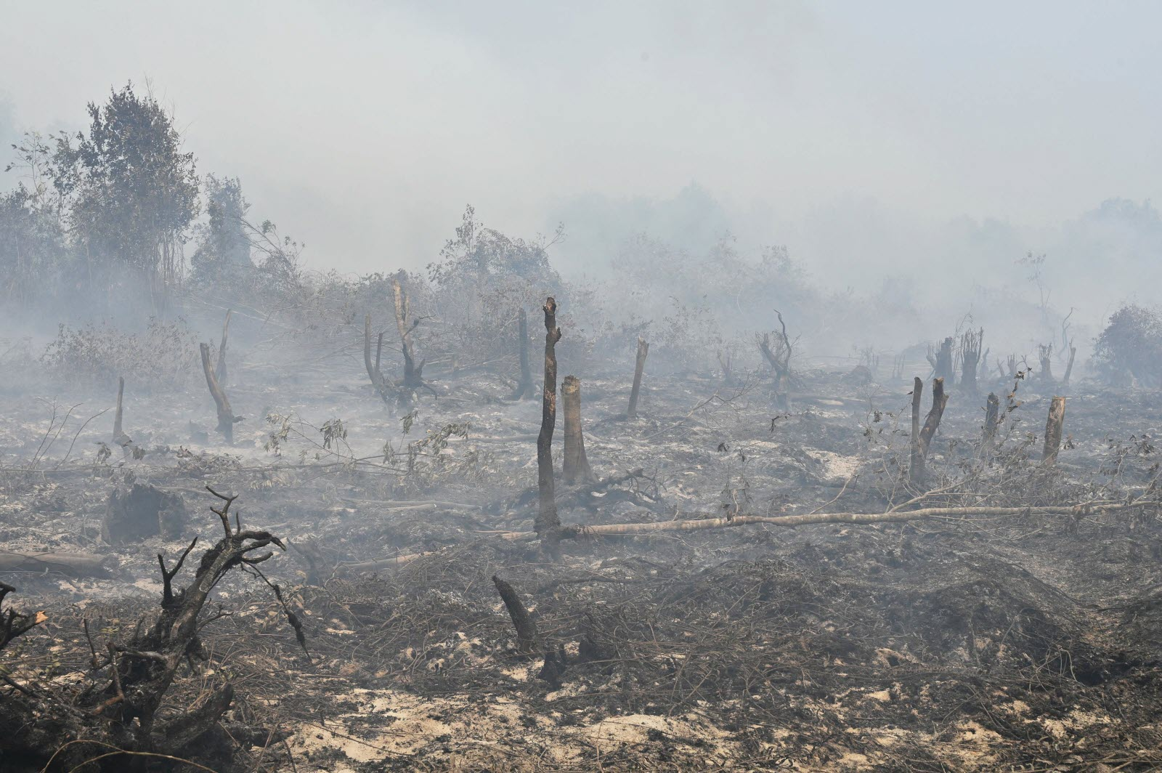
Credits: Adek Berry/AFP
https://www.manilatimes.net/2019/09/22/news/top-stories/indonesia-forest-haze-reaches-ph/620008/

1. What does this image depict? Where do you think this is situated in?

2. What do you think the above scenario is a result of?

3. What are the detrimental effects caused by it? State at least 3 examples.

4. How do we protect ourselves from the detrimental effects? State at least 3 examples.

5. What do countries need to do to prevent the above scenario? What can we as individuals do?
Recommended Solutions (Activity Sheet 1)

1. The image depicts a smouldering peatland in Kampar, Riau province. The surrounding air quality has also depleted, as evident from the haze in the surroundings.

2. The burning of peatlands in forest fires. Fine dust, smoke, vapors and dry particles were produced, obscuring the clarity of the sky and reducing air quality.

3. Short-Term Impacts:
- Irritation to eyes, nose and throat.
- Difficulty in breathing for people with existing chronic heart or lung diseases, heart failures, etc.
Long-Term Impacts:
- Prolonged exposure can result in an increased risk of cardiovascular effects (heart attacks, etc.), reduced lung development, development of chronic respiratory diseases (asthma, etc.).

4. Ways to protect ourselves:
- Drink more water.
- Reduce prolonged, strenuous activities.
- Reduce outdoor physical activities.
- Wear masks.
- Using air purifiers/air ionisers in indoor spaces.
- Close windows, doors when PSI levels are relatively high (>=100).

5. (Any solution is possible)
One example would be:
There needs to be the strengthening of legislation in countries to establish laws against the burning of peatlands and forests.
Consumption of sustainable agricultural products (i.e. RSPO certified palm oil products) that employ planting methods that do not include usage of fires, deforestation, new development on peatland, and no social exploitation.

In-class Activity Sheet 2: Peat Fires and Wildlife

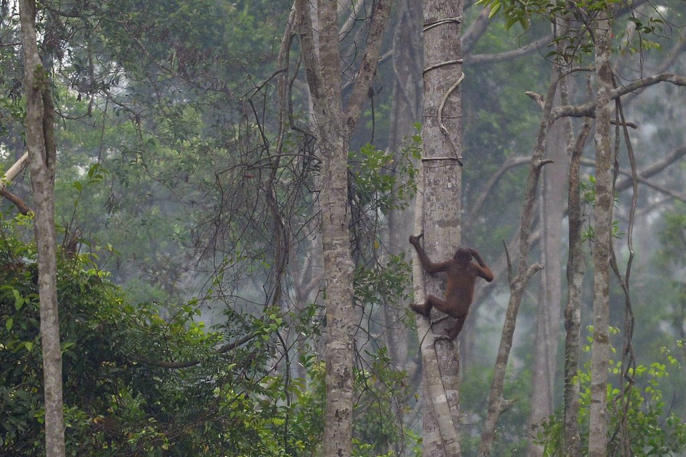
Credits: The New York Times
https://static01.nyt.com/images/2015/10/31/world/31indonesia/31indonesia-jumbo-v3.jpg

Questions:
- Where is this orangutan’s habitat?

- How do you think forest fires will affect orangutans?

- What can be done to help orangutans who have lost their natural habitats to forest fires? How effective will these measures be?

- What other species will be affected by forest fires? What broader environmental and societal consequences might there be?

Recommended solutions (Activity sheet 2)

- Treetops (in forests in Indonesian Borneo)

- Loss of habitat, respiratory infections, burns and other injuries (from source: a male orangutan’s eyes had been damaged by burning debris)

- They can be rescued and brought to rehabilitation centres.
Limited effectiveness
- Impossible for conservationists to rescue all orangutans affected by forest fires
- If orangutans are kept at rehabilitation centres for too long, they might lose their ability to survive in the wild/ baby orangutans cannot develop such an ability

- Elephants, birds, snakes, insects, etc (any animal or plant species found in peatland forests)
- Loss of biodiversity - might drive some species to extinction
- Especially detrimental for species which are already endangered e.g. orangutans, Sumatran elephants, Sumatran tigers
- Wildlife might flee towards areas occupied by humans → human-animal conflict
- Reduced bee populations → hurt agricultural production in Indonesia since bees are crucial for pollination of many crops

